

***ENTRY FORM***

***STATEMENT / TERMS OF RESPONSIBILITY***

***foreign clubs, international federations, associations, organizations, dojos, unions, universities, colleges, gymnasiums, schools, palaces and children's clubs, individual person***

***I, _____________________________ the undersigned, as the Chief of Delegation of my country/team, duly***

***enrolled to participate in the W.S.E.K.U. 35th Bihor Open - 2nd WORLD EUROPEAN REGIONAL CHAMPIONSHIP Karate-Kobudo-Parakarate which will be held in Oradea, Romania from 6-9 June 2024, with full knowledge of the Statutes, the Rules and the Norms of the World Sport Education Karate Union, pledge myself to faithfully accomplish the regulations of this before mentioned entity,***

***and I take any and all administrative, civil and criminal responsibilities of whatever happens to our athletes,***

***coaches and other members of our delegation participating in this championships, before, during and after the***

***competition, such as physical injuries, personal expenses, or monetary debts and casual material damages to***

***the hotels, the venue, means of transportation, departure on time, etc.***

***Furthermore, I exempt from any legal, civil or criminal responsibilities the organizers of the game, the World Sport Education Karate Union, its directors, as well as any person, company, or entity related to the event (sponsors, public and private entities).***

***I authorize the organizers of the event to use images, photos and the names of our competitors and other***

***members of our delegation (as considered necessary) for the sport activities and publications of karate, related***

***to the event, without any monetary compensation.***

***Dated: __________________________ Signature: ______________________________***

***Country/Nation***

***Surname, First Name***

***Passport No. & Expiry Date***

***Email Adress***

***Web Adress***

***Personal phone number:***

***Adress***

***STATEMENT / TERMS OF RESPONSIBILITY are mine the undersigned, _____________________***

***as head of my country/team delegation.***

***Entries please not later than 01.June.2024. on E-mail:*** [***secretariat.shogunul@gmail.com***](mailto:secretariat.shogunul@gmail.com)

***______________________________________________________________________________________________***

***Name of the Karate Club :***

***City:***

***Country :***

***Telefon / Phone number :***

***E-mail :***

***Website :***

***Responsible person :***

***Coaches / Team leader’sname:***

***Referees :***

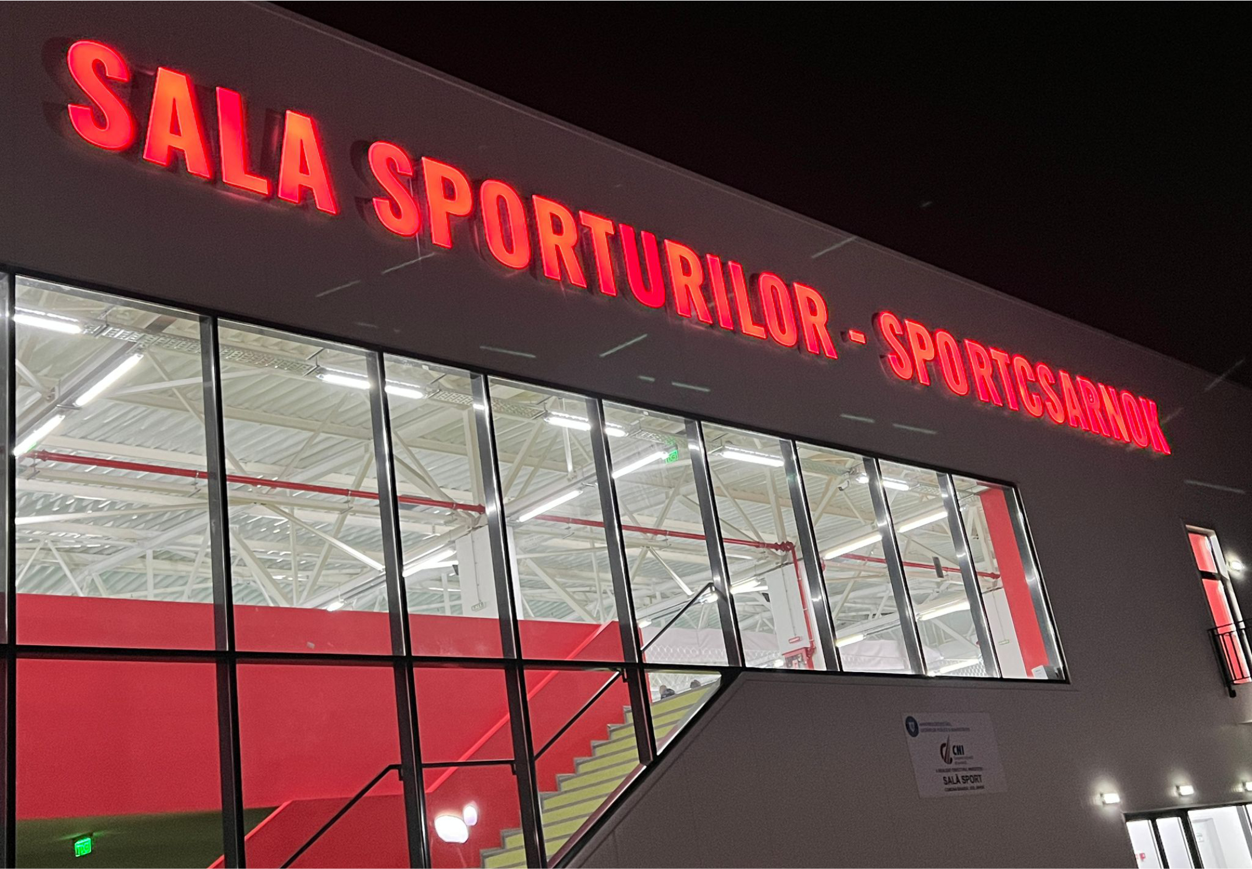

|  |  |  |  |  |  |  |  |  |  |
| --- | --- | --- | --- | --- | --- | --- | --- | --- | --- |
| ***Nr.*** | ***Name and surname of the competitor:*** | ***Date of birth*** | ***full age*** | ***Current Weight (kg)*** | ***sex***  ***(M/F)*** | ***Individual***  ***Kata Categories code:*** | ***Individual* *Kumite Categories code:*** | ***Belt Color Category*** | ***Grade***  ***KYU-DAN***  ***Category*** |
| ***1.*** |  |  |  |  |  |  |  |  |  |
| ***2.*** |  |  |  |  |  |  |  |  |  |
| ***3.*** |  |  |  |  |  |  |  |  |  |
| ***4.*** |  |  |  |  |  |  |  |  |  |
| ***5.*** |  |  |  |  |  |  |  |  |  |
| ***6.*** |  |  |  |  |  |  |  |  |  |
| ***7.*** |  |  |  |  |  |  |  |  |  |
| ***8.*** |  |  |  |  |  |  |  |  |  |
| ***9.*** |  |  |  |  |  |  |  |  |  |
| ***10.*** |  |  |  |  |  |  |  |  |  |
| ***11.*** |  |  |  |  |  |  |  |  |  |
| ***12.*** |  |  |  |  |  |  |  |  |  |
| ***13.*** |  |  |  |  |  |  |  |  |  |
| ***14.*** |  |  |  |  |  |  |  |  |  |
| ***15.*** |  |  |  |  |  |  |  |  |  |
| ***16.*** |  |  |  |  |  |  |  |  |  |
| ***17.*** |  |  |  |  |  |  |  |  |  |
| ***18.*** |  |  |  |  |  |  |  |  |  |
| ***19.*** |  |  |  |  |  |  |  |  |  |
| ***20.*** |  |  |  |  |  |  |  |  |  |
| ***21.*** |  |  |  |  |  |  |  |  |  |
| ***22.*** |  |  |  |  |  |  |  |  |  |
| ***23.*** |  |  |  |  |  |  |  |  |  |
| ***24.*** |  |  |  |  |  |  |  |  |  |
| ***25.*** |  |  |  |  |  |  |  |  |  |

*Date: ______________, 2024. _______. ___. ______________________*

*signature of coach / team leader*